Title of the Presentation

F. Donatini,^{1),*} J. Lähnemann,²⁾ G. Jacopin,¹⁾ R. Oliver ³⁾and J. Pernot¹⁾

¹⁾ Univ. Grenoble Alpes, CNRS, Grenoble INP*, Institut Néel, 38000 Grenoble, France
²⁾ Paul-Drude-Institut für Festkörperelektronik, Hausvogteiplatz 5−7, 10117 Berlin, Germany
³⁾ University of Cambridge, 27 Charles Babbage Road, Cambridge CB3 0FS, United Kingdom

*Corresponding author: fabrice.donatini@neel.cnrs.fr

Each abstract is limited to a maximum of 2 pages for a 30 min presentation and 1 page for each 15 min presentation, including text, references, and figures. Please use the following page setup as shown in this template: A4 size paper, 2 cm left and right margins, 2.5 cm top and bottom margins, Arial font, title in headline style (capitalised) with 12 pt bold font, authors in 10 pt bold font, affiliation and the corresponding author in 9 pt italic, and normal text in 10 pt font.

Equations
Should be centred and numbered consecutively with equation numbers in parentheses right-aligned:

$T_{s}=\frac{T_{b}}{1+\left({{λT}_{b}}/α\right)\text{ln}\left(ε\right)}$ (1)

Abbreviations and Acronyms
Please define abbreviations and acronyms the first time they are used in text.

File Type and Size
The paper should be submitted in .docx format with a maximum file size of 10 MB. Please name the file with the corresponding author’s last name.

References
Please number citations consecutively in square brackets [1].

[1] J. Lähnemann, U. Jahn, O. Brandt, T. Flissikowski, P. Dogan, and H. T. Grahn, J. Phys. D: Appl. Phys. 47, 423001 (2014).

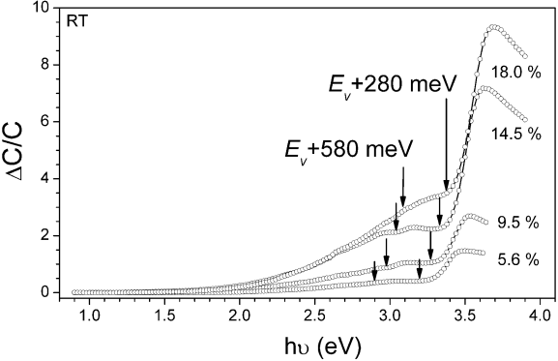
Fig. 1: Figure and figure caption should be centered in the page. Please use 9 pt font for the figure caption.

